|  |
| --- |
|  |
|  |
|  |

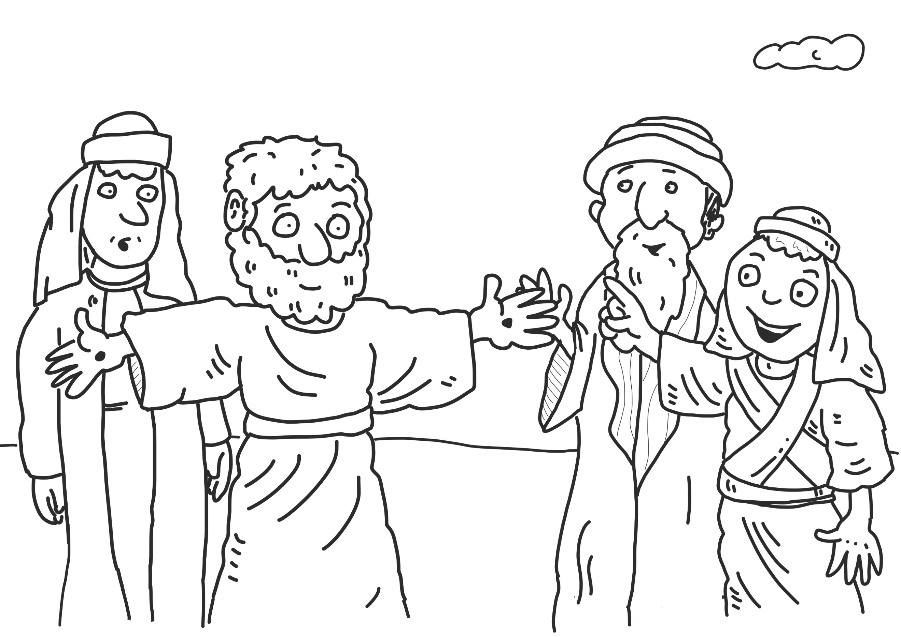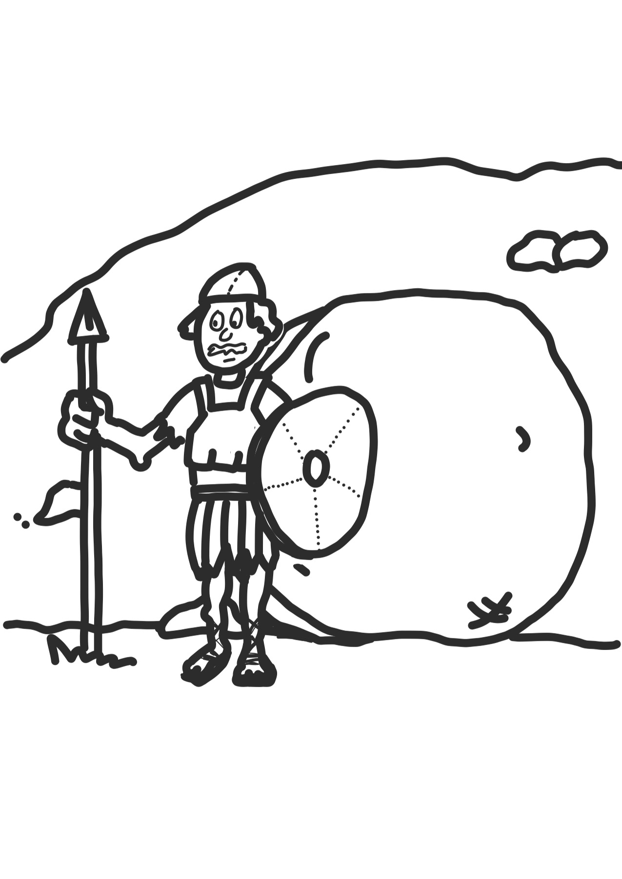

Pretend that you are a newspaper journalist. You have been asked to interview one of the disciples walking along the road to Emmaus with Jesus. Write a list of the questions you would ask the disciple.

Read Luke 24:1-53. Draw or write a timeline of the events as recorded in Luke between Jesus’ resurrection and ascension