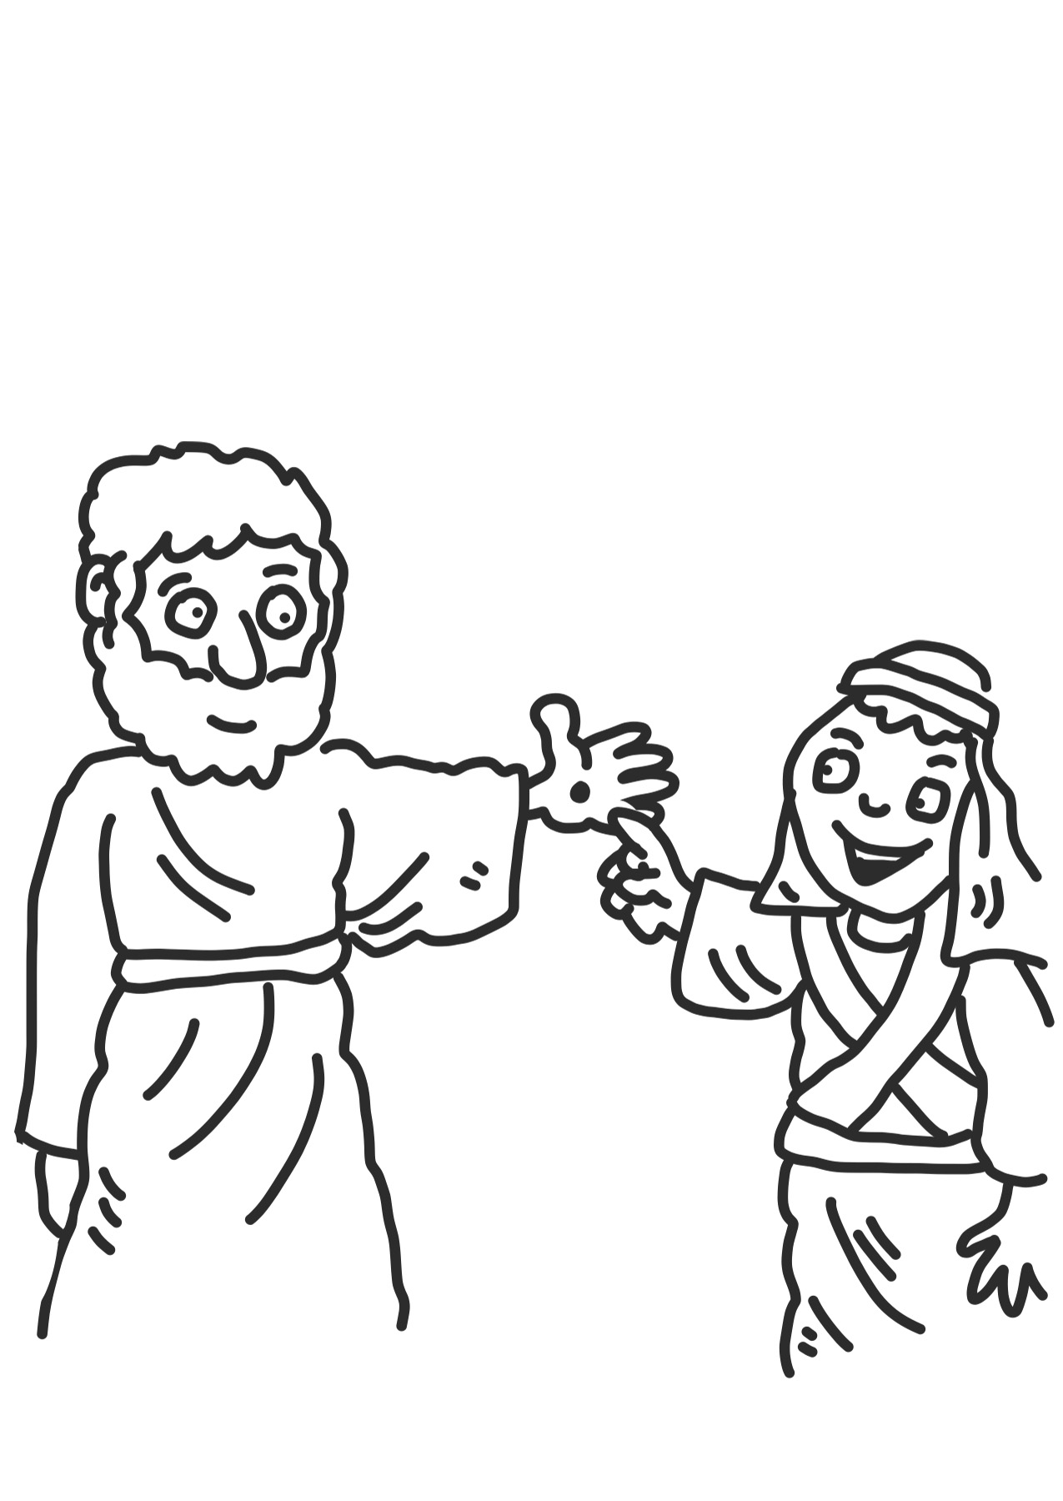
Read Acts 2 on Biblegateway.com. The table below seeks to re-tell the events in Acts 2. Draw a picture based on your reading of the passage to explain what is happening in each box.

The Apostles are all together in one house. A sound like the blowing of a violent wind fills the whole house. | Peter speaks to the crowd and tells the crowd about Jesus.
What seem like tongues of fire come to rest on each of the Apostles and they begin to speak in other languages. | Around 3000 people are baptised.
A large crowd comes to see what is happening. | All the believers were together and shared their possessions with each other.

Write a job description for the Holy Spirit based on Acts 2.

