What have you learnt from this unit?

What questions do you still have about Jesus?

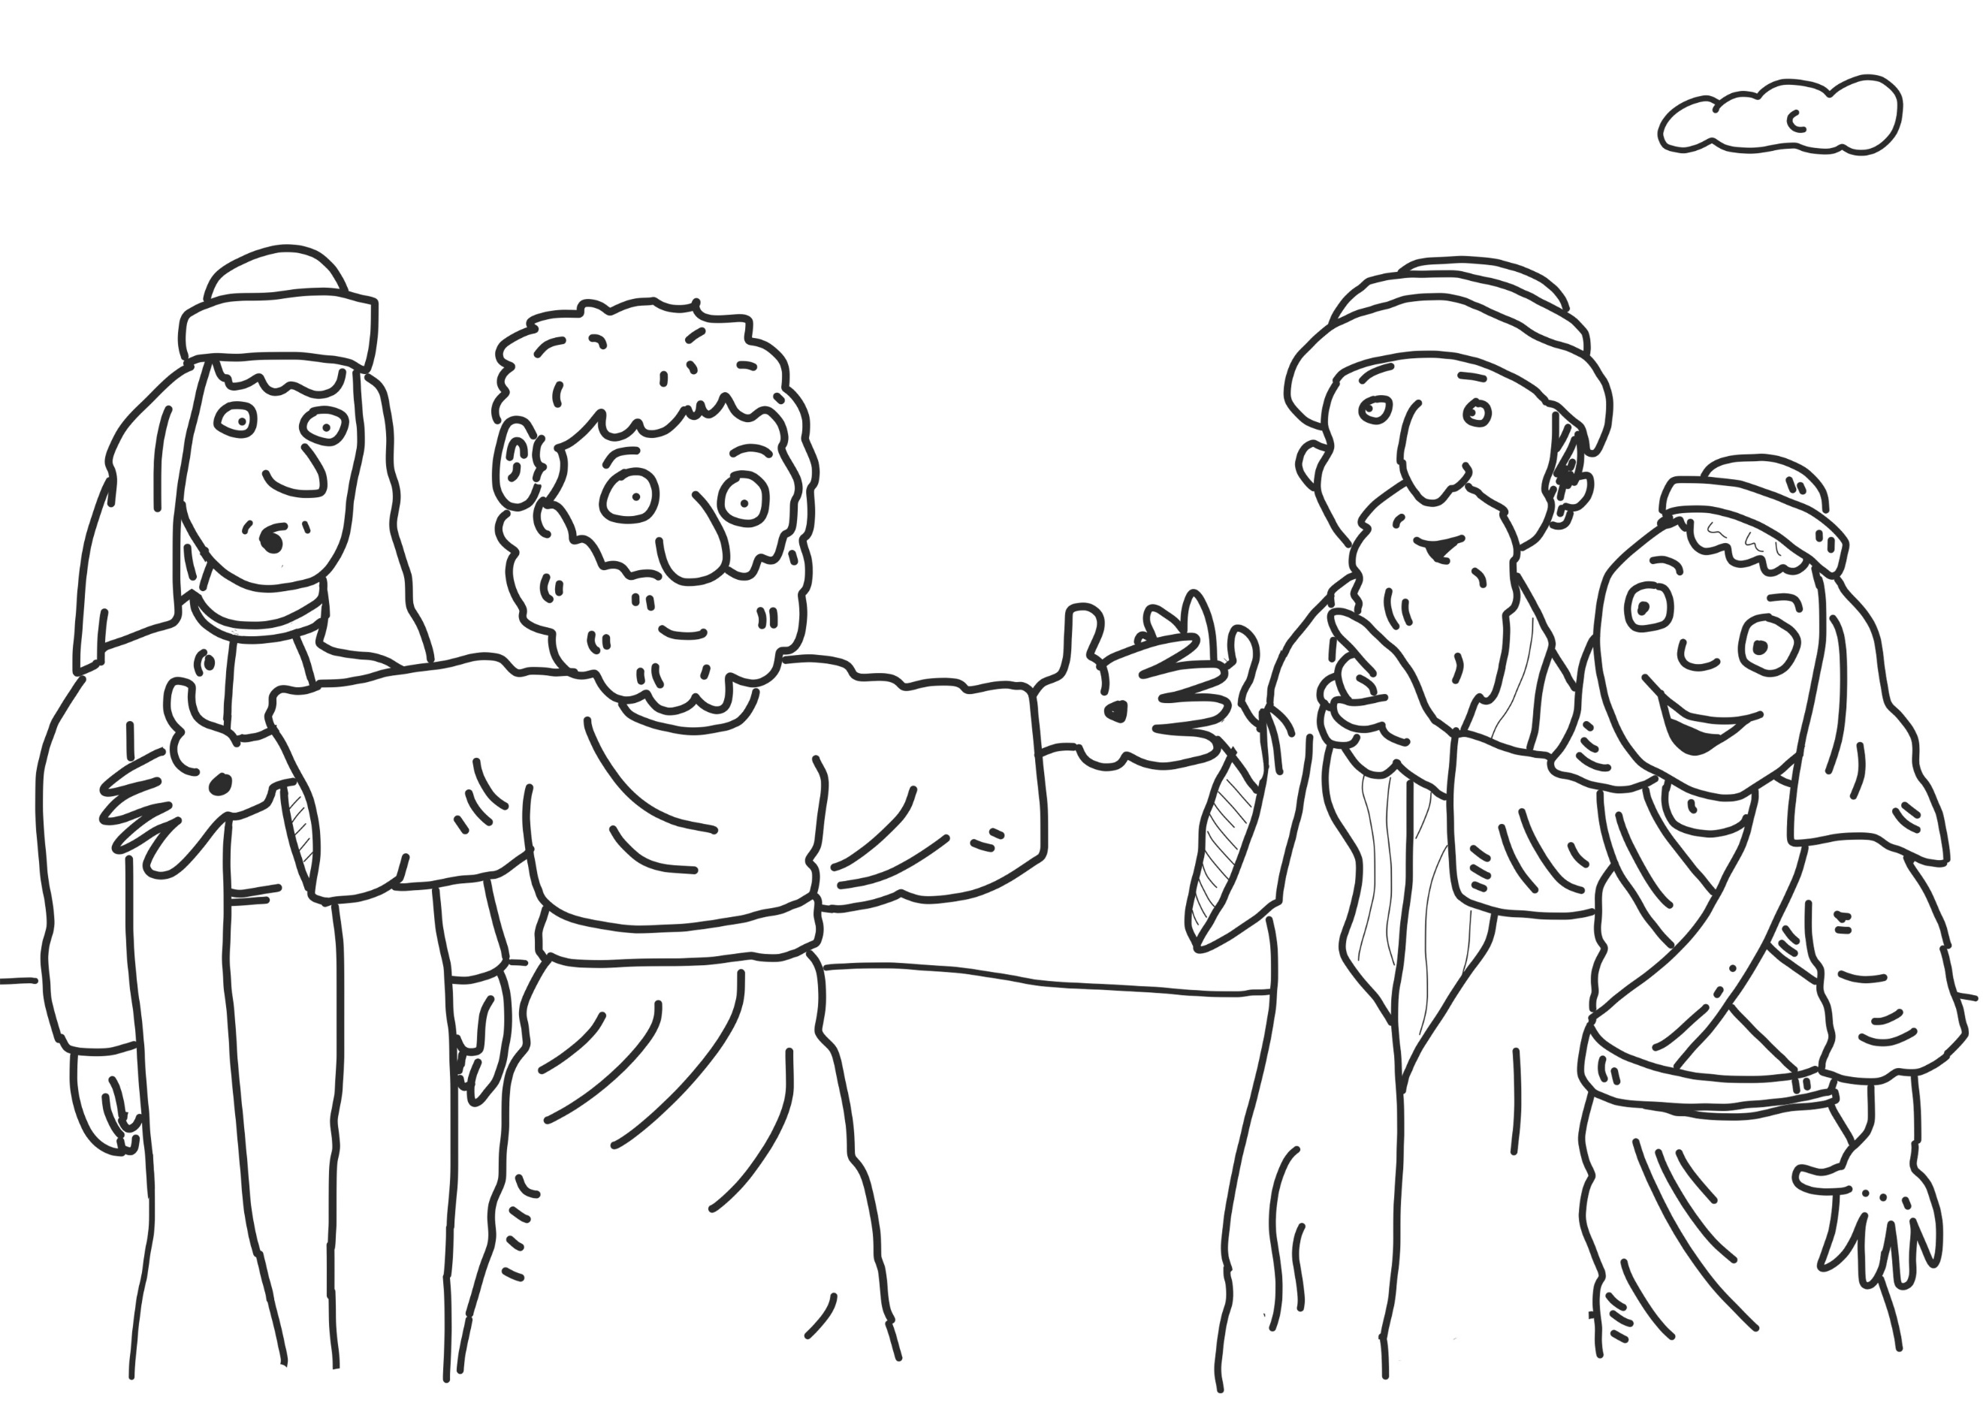

How would someone who believed the resurrection was true act in response to this unit?

How would someone who believed the resurrection of Jesus did not occur act in response to this unit?

What does the festival of Pentecost mean to you?

?

