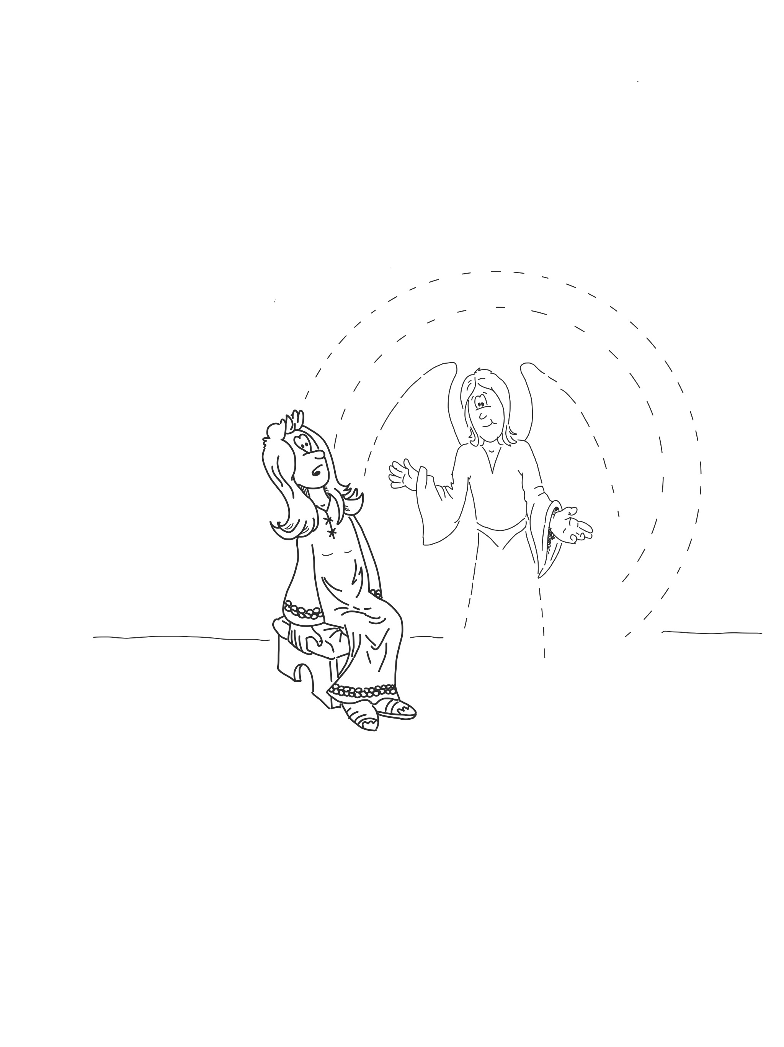
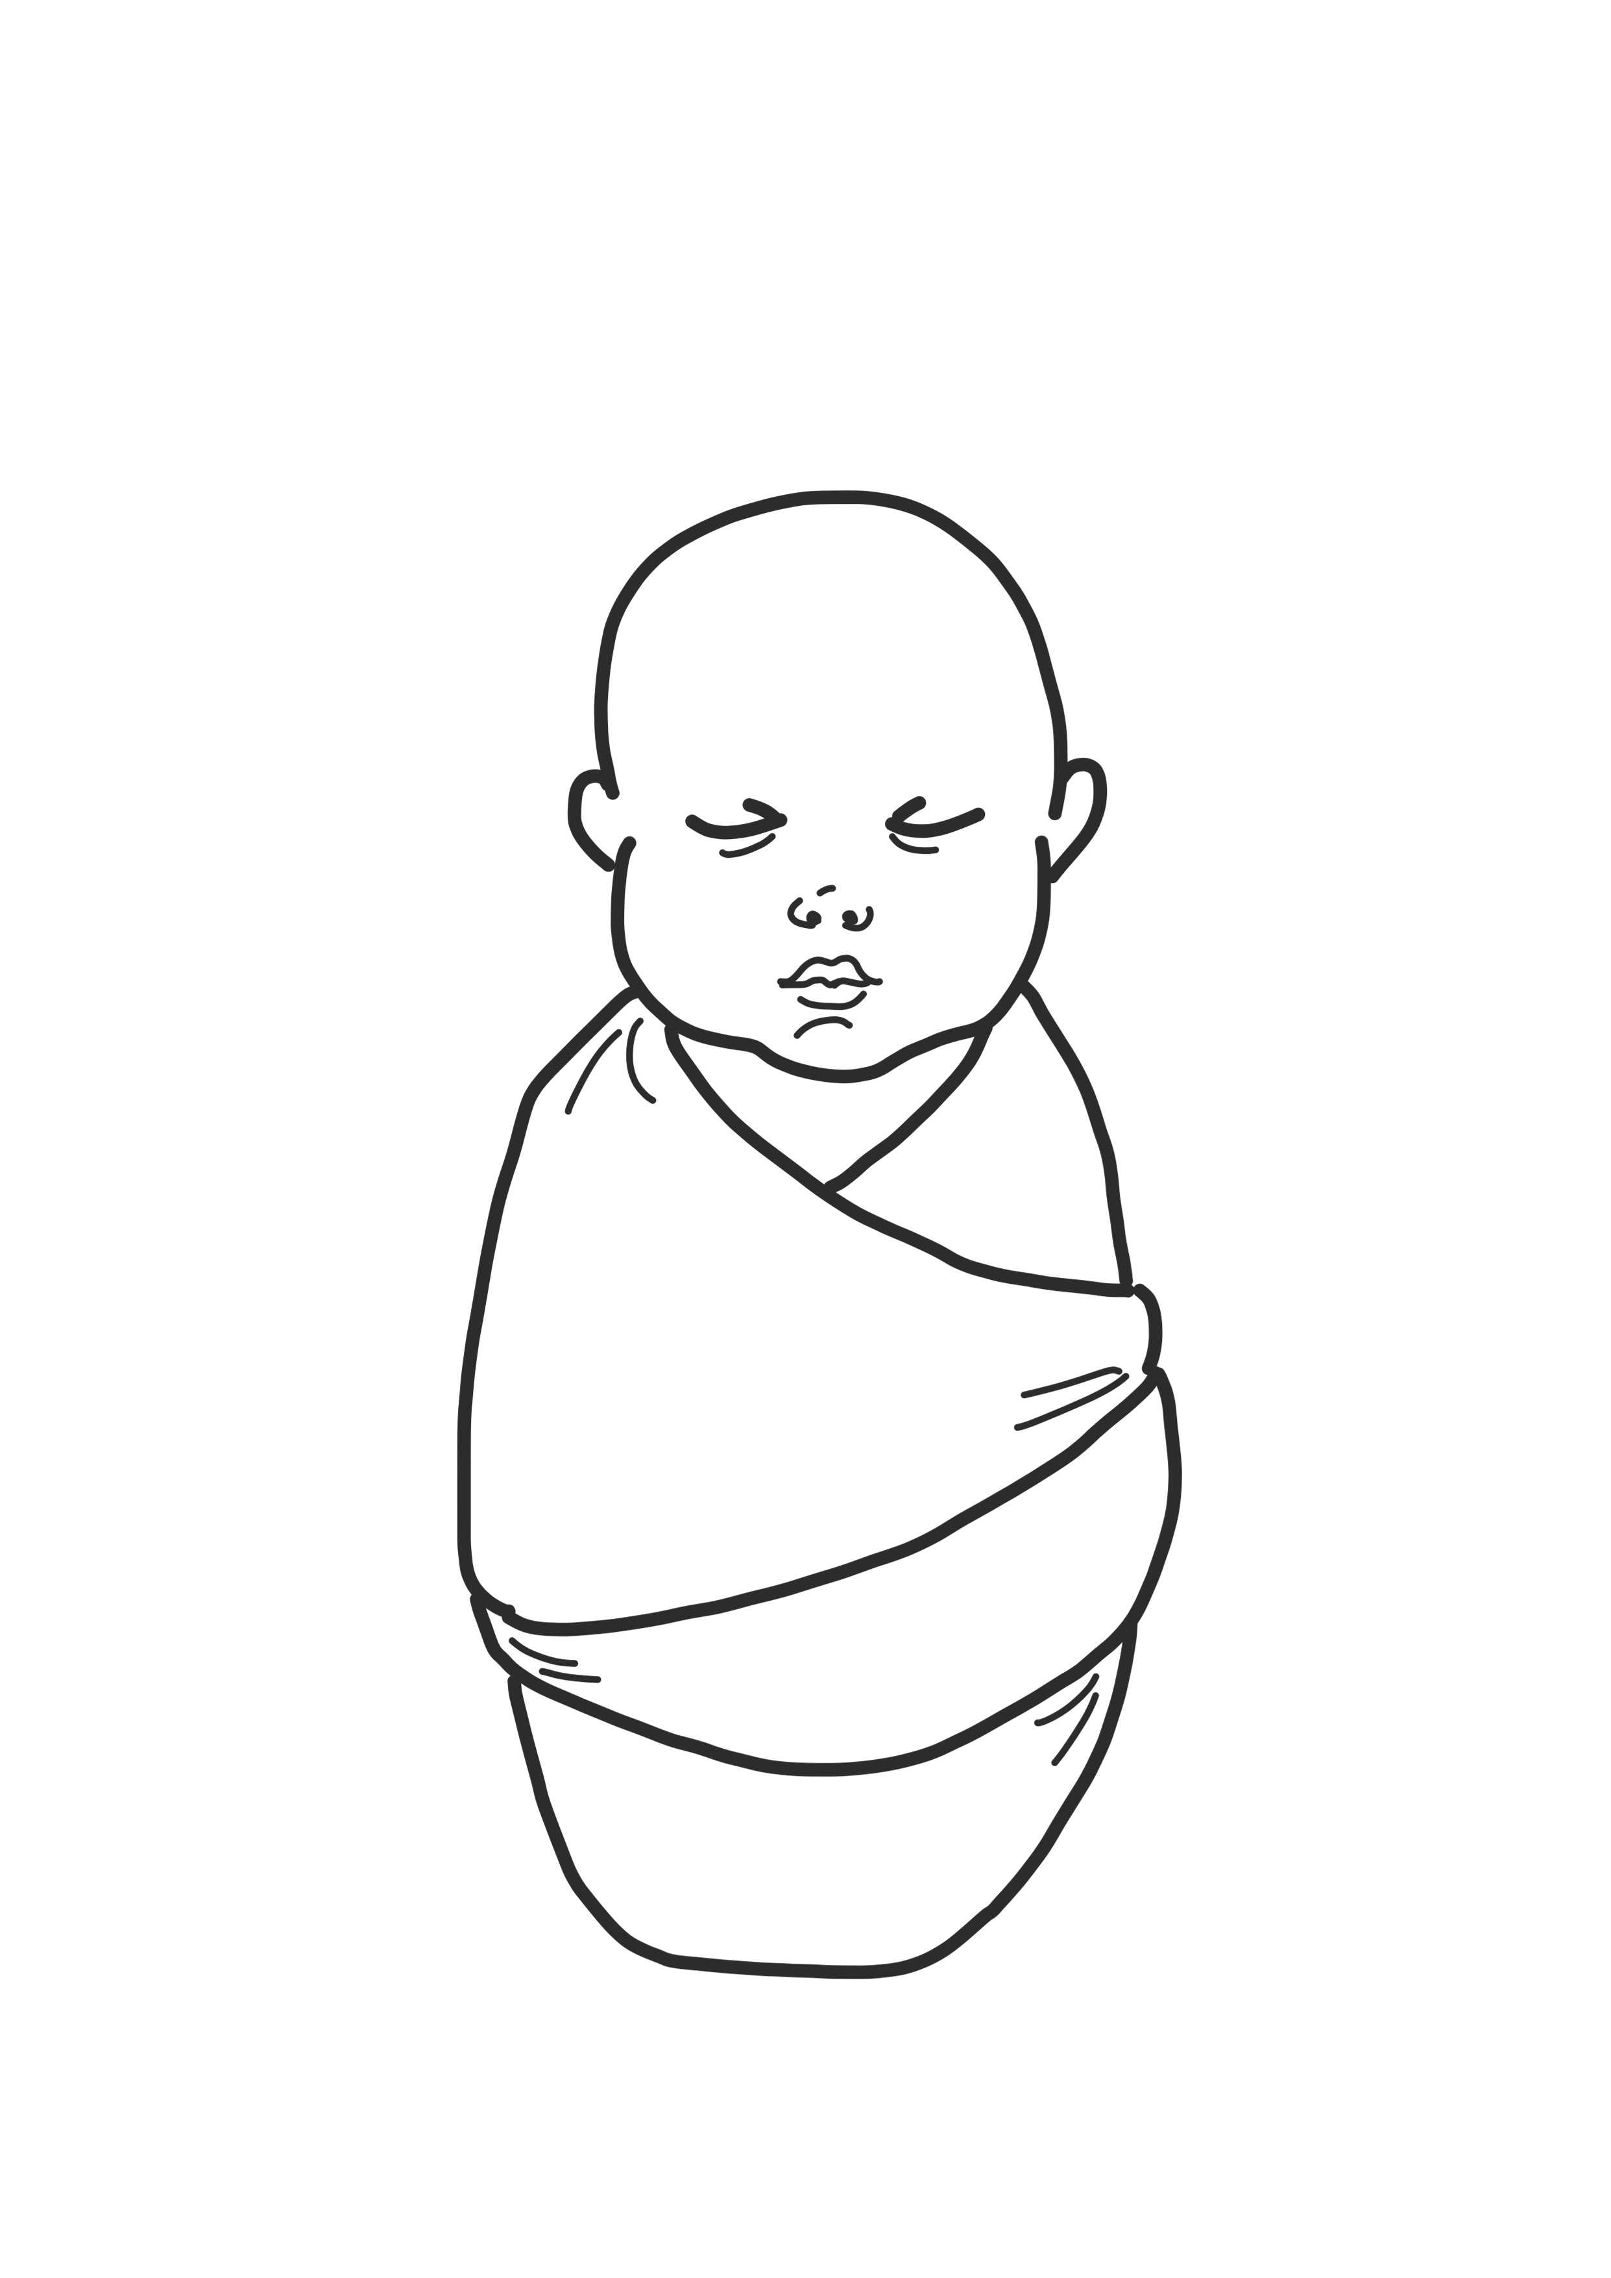
Read Luke 1:26-38 on BibleGateway.com. Around the picture of Mary and Jesus record what the passage tells us about each person.

The passage tells us that Mary was greatly troubled by the words the angel spoke to her. Imagine you are Mary. Write a diary entry below reflecting on your encounter with the angel.

