1. Look through the pages of the Bible and write down anything you notice about it. Look at titles, headings, the way it’s organised and what additional features it has.

2. How is it different to a normal book?

3. Look at the contents page. How is it organised?

4. Choose one chapter of the Old Testament to read (use the contents to figure out which parts are the Old Testament). Which did you choose?

5. What did it talk about?

6. Choose one chapter of the New Testament to read (use the contents to figure out which parts are the New Testament). Which did you choose?

- What did it talk about?

- How many different books make up the Bible?

- See if you can find examples of any of the following kinds of writing in the Bible. Write down the references next to them:

Poetry/Song Lyrics:
Stories:
Letters:
Laws:
Wise Sayings:

9. If you finish all these questions, spend the rest of your time reading through as much of ‘Mark’ as you can. This is the earliest biography written about Jesus. What was interesting about the story?

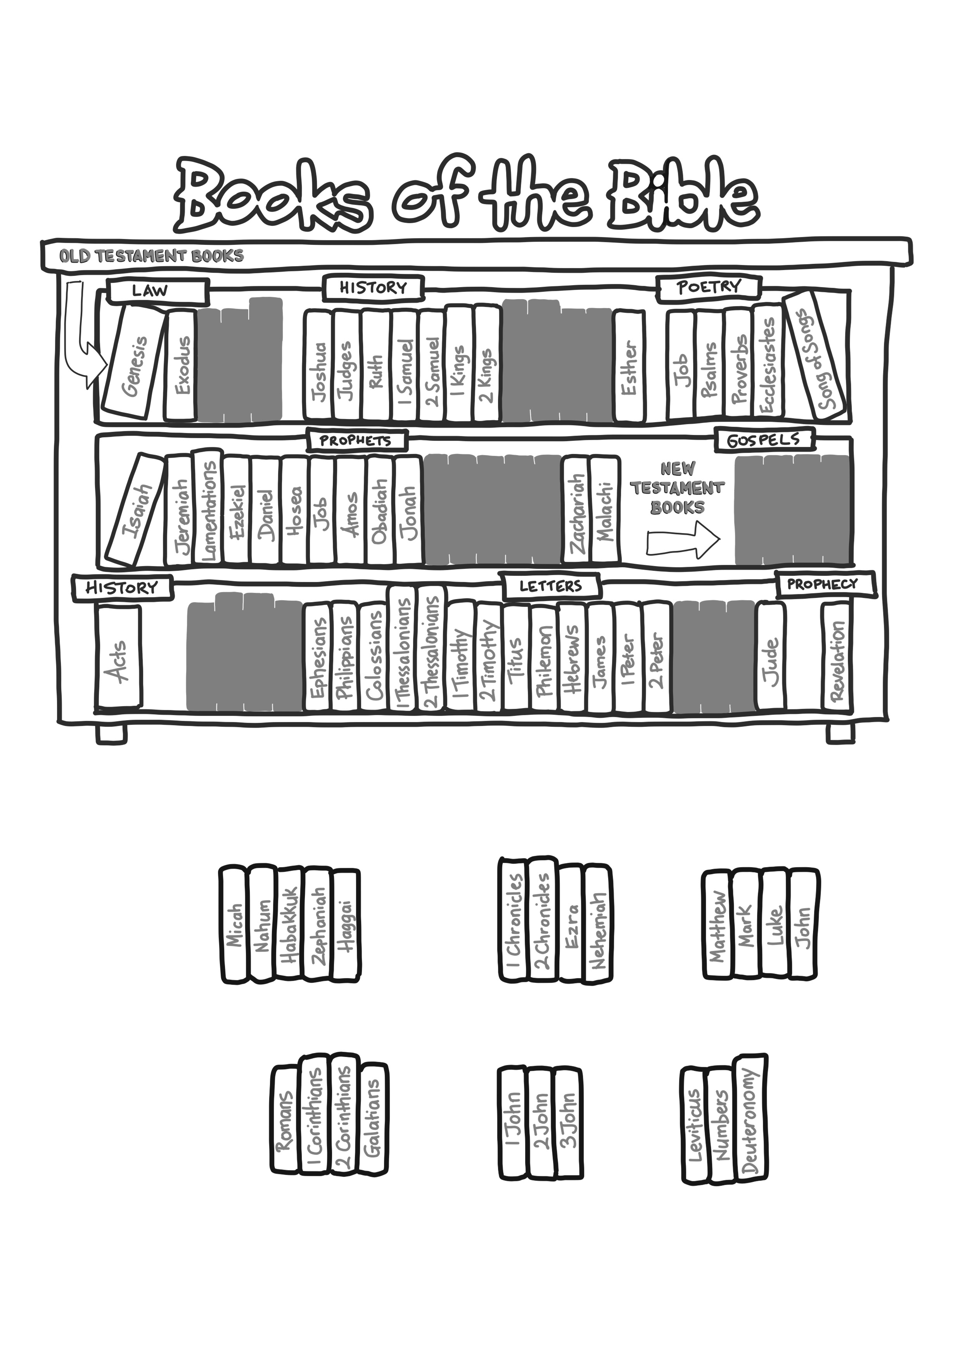
Cut out the missing books and stick them into the correct location on the bookshelf.
?

