Open your Bible (or use Biblegateway www.biblegateway.com ) and find the book of Psalms.
Answer the questions below.
Psalm 117
Praise the Lord, all you nations;
extol him, all you peoples.
For great is his love toward us, and the faithfulness of the Lord endures forever.
Which number book in the Bible is it? ______

What is the book before the Psalms?______________

What is the book after the Psalms?________________

How many Psalms are there? ___________________

What is a Psalm?
Write a definition in your own words.
A psalm is… ________________________________________________________________________________________________________________________________________________________________________
There are many different types of psalms written by different people.
Look at these psalms —who does the text say the writers are likely to be?
PSALM AUTHOR
4 _______________________
56 _______________________
50 _______________________
72 _______________________
89 _______________________
90 _______________________

Let’s read a psalm!
Psalm 150 (CEV)
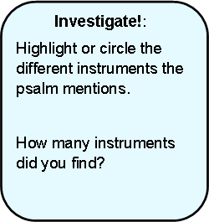
¹Shout praises to the Lord!
Praise God in his temple.
Praise him in heaven,
his mighty fortress.
² Praise our God!
His deeds are wonderful,
too marvellous to describe.
³ Praise God with trumpets
and all kinds of harps.
⁴ Praise him with tambourines
and dancing,
with stringed instruments
and woodwinds.
⁵ Praise God with cymbals,
with clashing cymbals.
⁶ Let every living creature
praise the Lord.
Shout praises to the Lord!

What does the writer want people to do? How?
_______________________________________________________________________________________________________________________________________________________________________
How does reading Psalm 150 make you feel? Why? ___________________________________________________________________________________
___________________________________________________________________________________

?

