Do you find it easy or hard to be thankful? Why?
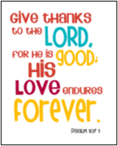

List 3 things you are thankful for right now

1.__________________________________________________ 2._________________________________________________ 3.__________________________________________________________________
Is there someone you can thank for these things? If so, who?

______________________________________________________________________________________________________________________
Some of the psalms are Thank You psalms which thank God for lots of different things.
Often the psalm writers remember hard times and say thank you to God for helping them through.
Psalm 30 is a good example.
Here is verse 1:
I praise you, Lord, because you have saved me
and kept my enemies from gloating over me.
(Quick check: What does gloating mean?)
In other Psalms the writers just say thank you for what God has done for them!

PSALM 138 v1-3 (The Message)
DISCUSS:
1. What is the writer of Psalm 138 thankful for?
2. How many times does “Thankyou” appear in these verses?
3. Why do you think this is?
⁻Thank you! Everything in me says
“Thank you!”
Angels listen as I sing my thanks.
I kneel in worship facing your holy temple
and say it again: “Thank you!”
Thank you for your love,
thank you for your faithfulness;
Most holy is your name,
most holy is your Word.
The moment I called out, you stepped in;
you made my life large with strength.

Psalm 100 (CEV)
¹ Shout praises to the Lord,
everyone on this earth.
² Be joyful and sing
as you come in to worship the Lord!

³ You know the Lord is God!
He created us,
and we belong to him;
we are his people,
the sheep in his pasture.

⁴ Be thankful and praise the Lord
as you enter his temple.
⁵ The Lord is good!
His love and faithfulness
will last forever!

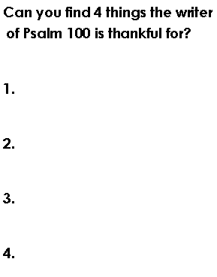
Work with the class or a partner to rewrite Psalm 100 in your own words.

