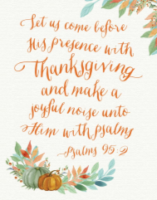
The Psalms were written to be used in worship, mainly to be sung.
More than a third are addressed to “the Director of Music”. Look in a Bible and see if you can find 3 of them. Write their numbers here:

Some psalms also give instructions on what instruments should be used. Which instruments are suggested for the following Psalms?
Psalm 4: _______________________
Psalm 5: _________________________

Many Psalms also encourage people to sing. Copy the first verse of Psalm 96
___________________________________________________
___________________________________________________
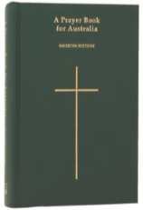
PSALMS IN ANGLICAN WORSHIP
Psalms are used every day in different kinds of Anglican church services.
They are used in morning and evening prayer, in Eucharist services, in baptisms, funerals, memorials and more. The book of Psalms is included in Anglican Prayer books.

In worship services with a choir or music leader the psalm is often sung. If there is no choir, the psalm can be read out loud in different ways. Here are 3 of the most common ways:
1. A solo reader reads the whole psalm.
2. A reader leads the Psalm—they read the odd verses, the congregation say with the even verses.
3. A reader reads the first part of the verse (up to the colon) then the congregation says the second half of the verse.
Find Psalm 95.

Discuss:
1.Do you think reading the Psalm in the different ways above helps you understand it? Why or why not?
2. What type of Psalm do you think this is? How do you know?

___________________________

___________________________

SINGING THE PSALMS
The Psalms are sung in churches all over the world – in many different styles.
Listen to some traditional Anglican church choirs singing psalms (see the links in the lesson plan).
Describe the musical style of these psalms (e.g. loud/soft; fast/slow; kind of beat etc)
______________________________________________________________________________________________________
How might this musical style help people worship God? (What would it make them feel, think about? How could it help them think about the words of the Psalms?)
_____________________________________________________________________________________________________

