Looking at this I realised that…

I noticed…

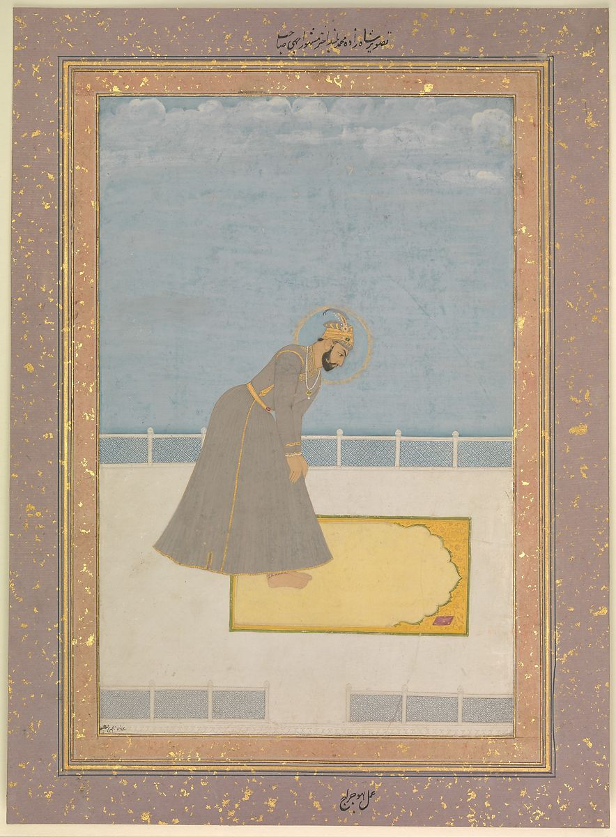

What an atheist might think about this picture is…

What a Christian might think about this picture is…

What a Muslim might think about this picture is…

My imaginative title for this image is…

The main message of the picture is…

This made me think more deeply about…

I’m not sure about…

Portrait of Prince Muhammad Buland Akhtar at Prayer by Bhojraj ca. 1700-1750.