The Five Pillars of Islam are the core beliefs and practices of Islam. The Five Pillars are outlined most clearly in the Hadith of Gabriel.

Research each pillar and record a brief description in the table below.

Pillar | Description
Shahada
Salat
Zakat
Sawm
Hajj
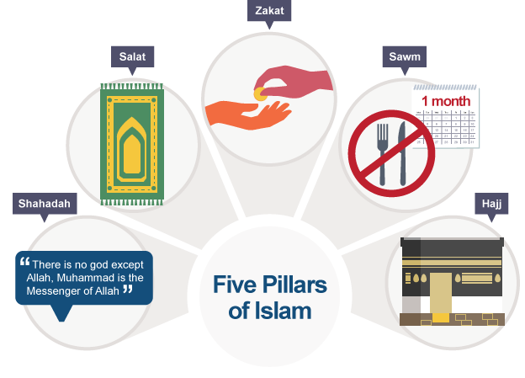

Source:https://www.bbc.co.uk/bitesize/guides/zwkky4j/revision/1

