Dear Diary,
Wow! What a day! I can’t believe I’m finally here
in Makkah! After a lifetime of saving up and finding the right opportunity
to come... and I’m here! It feels so special to be able to complete the
fifth pillar of my religion.
So our flight was very hot but very exciting. We were all Muslims together, all going for the same purpose – so we were all very excited. Going into the state of Ihram was quite a milestone. When we all put on our white robes, and said our first prayers – it felt like Hajj properly for the first time.
The first thing we did was TAWAF; walking around the Kab’ah seven times. The Kab’ah was much bigger than I thought it would be. I took this picture while I was there...
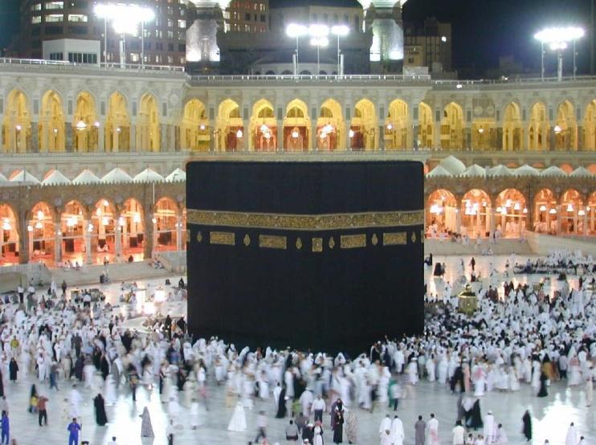

When we were walking round seven times, I felt great because I was following out Allah’s instructions from the Qur’an – and because I felt really connected with everyone else who was doing the same thing
Next, I went and drank the water from the Zam Zam well. It tasted very sweet for some reason, and felt really special, because I knew this was the well that was created to stop Ishmael from dying of thirst in the story in the Qur’an!
Lastly today, we all did the walk between the two hills (SA’Y). This remembers the same story in the Qur’an, where Hagar runs between the mountains trying to find water for Ishmael (her son). We walked up and down 7 times between the two hills. It felt really special to be retracing Hagar’s exact steps!
But now I’m so tired! So much walking today! But it is so worth it. This is a once in a lifetime experience (literally!) Goodnight diary – I will write again tomorrow if I have any energy left!

Aliyah xx

