Makkah Times

7 Riyals

**Thousands of Muslims from all over the world join together at one time in one place in their holiest city – Makkah.** We catch up with some of them on the last day of their experience.

Our reporter interviews one Muslim who explains what he has done in his last few days... “After I got my head shaved, we all travelled back to Makkah and did tawaf again. You feel so united with every other Muslim walking around the Kab’ah 7 times – round and round to represent the unity of Allah.”

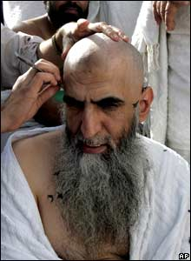

It does not stop there. It seems that Muslims then travel back to Mina on their last few days and stone the pillars each day. And after final prayers on the last day, Hajj is over. All women are now Hajjah’s, all the men are now Hajji’s.

And what is done to celebrate this momentous occasion? The final celebration of Eid ul Adha is then had by all Muslims on Hajj, and in fact, all Muslims all around the world, whether they went on Hajj or not! The height of this festival is the slaughtering of a sheep, remembering the story in the Qur’an where Isaac was willing to sacrifice his son Ishmael, but God spared him at the last minute.

[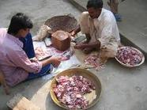](http://www.google.co.uk/imgres?imgurl=http://s3.hubimg.com/u/2246406_f520.jpg&imgrefurl=http://hubpages.com/hub/Eid-Ul-Adha&usg=__MR9pFowpxk32U9DDKBZKZNFdL2Q=&h=390&w=520&sz=44&hl=en&start=10&zoom=1&tbnid=4btznAsOy1ZTfM:&tbnh=133&tbnw=171&ei=dBvvTfiMCtSZhQfutMGqBw&prev=/search?q=eid+ul+adha&hl=en&biw=1024&bih=450&gbv=2&tbm=isch&itbs=1&iact=rc&dur=180&page=2&ndsp=10&ved=1t:429,r:5,s:10&tx=69&ty=51)

The sheep is then divided and spread around as food for the poor. Hajj seems like an amazing once in a lifetime experience for Muslims – especially since it is fulfilling the fifth of the five pillars!