What is a lament?
I am worn out from my groaning.
All night long I flood my bed with weeping and drench my couch with tears.
Psalm 6:6

What kinds of things do people lament about? (List 2 or 3 things)

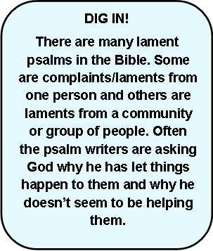
_____________________________________________________________________________________________________________________
Read Psalm 13 in your Bible or on BibleGateway. Copy verse one below.

What is the writer of Psalm 13 expressing sadness (lamenting) about?
___________________________________________________
___________________________________________________
What is the writer asking God to do for him/her? _________________________________________________
___________________________________________________

Look at the last 2 verses. How are they different to the rest of the Psalm?
___________________________________________________
___________________________________________________
___________________________________________________
Read these verses from Psalm 123

Psalm 123
¹Our Lord and our God,
I turn my eyes to you,
on your throne in heaven.
² Servants look to their master,
but we will look to you,
until you have mercy on us.
³ Please have mercy, Lord!
We have been insulted
more than we can stand,
⁴ and we can’t take more abuse from those proud,
conceited people.

What is the writer complaining
about/lamenting?
_______________________________________
_______________________________________
_______________________________________
What do you think the writer would
like God to do for them?
_______________________________________
_______________________________________

