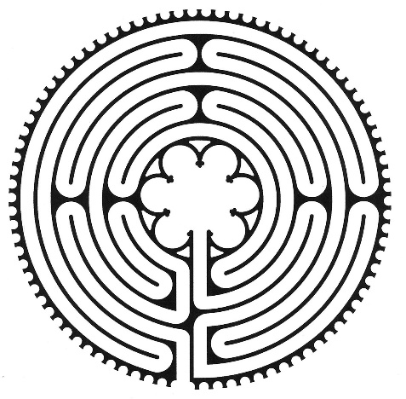
Guidelines for Walking the Labyrinth

The labyrinth is a pathway – it winds around from the outside to the centre, and back again. It looks a bit like a maze, but it is not a maze (bottom left). There are no tricks or dead ends like in the Harry Potter movie.

Labyrinths (like mazes) are known from ancient times, in Crete and Greece, and have been found on coins, or scratched into rocks
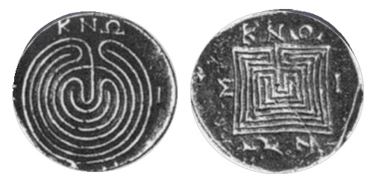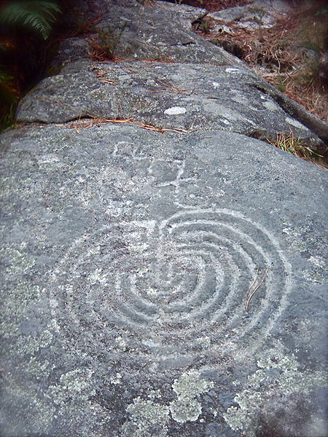
They come in many shapes and sizes, and nearly always people have seen the labyrinth as a spiritual or symbolic pathway.

Some, like ours, are big enough to walk on the path. Others are little ones, as small as a plate, you trace with your finger or a stylus. No matter the size or place, they are about movement.
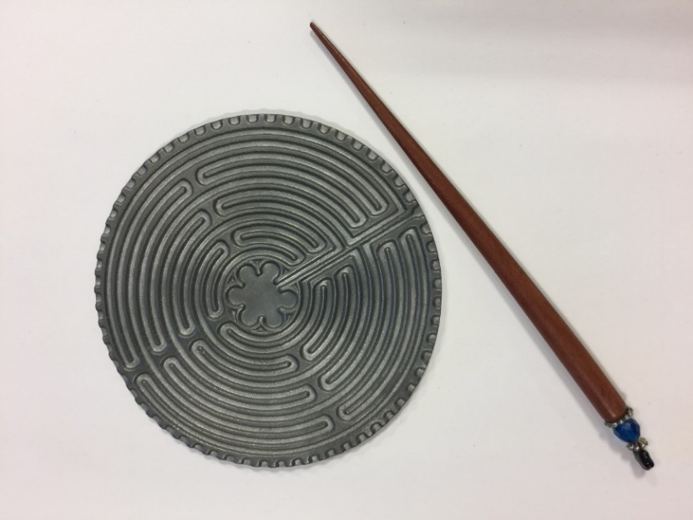
Big or small they form a journey – you follow it round and round to the centre, pause there, and then using exactly the same pathway in reverse, you return from the centre – the entrance becomes the exit!

The whole path is in full view the whole time, which allows you to be quiet and focus internally; to just follow your feet, or your finger. Unlike sitting and meditating, the labyrinth involves moving your body.

You will find that once you are on the path it is really easy to follow. You don’t need to think about it or work out where to go – it takes you on its own path, and leaves you free to walk on your own inner journey. That’s why it is usually walked in silence – even when lots of people are walking it together – so that each one is free to follow their own thoughts and feelings.

To prepare, you may want to sit quietly to reflect before walking the labyrinth. Some people come to use a labyrinth having questions in mind, some come during times of grief and loss, others just to slow down and take time out from a busy life. Some come to find strength to take the next step. Some come without any fixed idea of what it’s for, you just walk it, and maybe a purpose reveals itself as you walk.
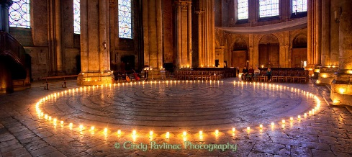
Our labyrinth is a scaled replica of the Chartres Labyrinth laid in the floor of Chartres Cathedral in France around 1220 C.E. It is the most famous, but there are many others throughout the world. They were used to help medieval pilgrims trying to follow in the footsteps of Jesus. Now, more and more churches and other people interested in the inner human journey are building permanent or temporary labyrinths. Some people have developed ways to understand the labyrinth journey that modern pilgrims like you might find helpful.
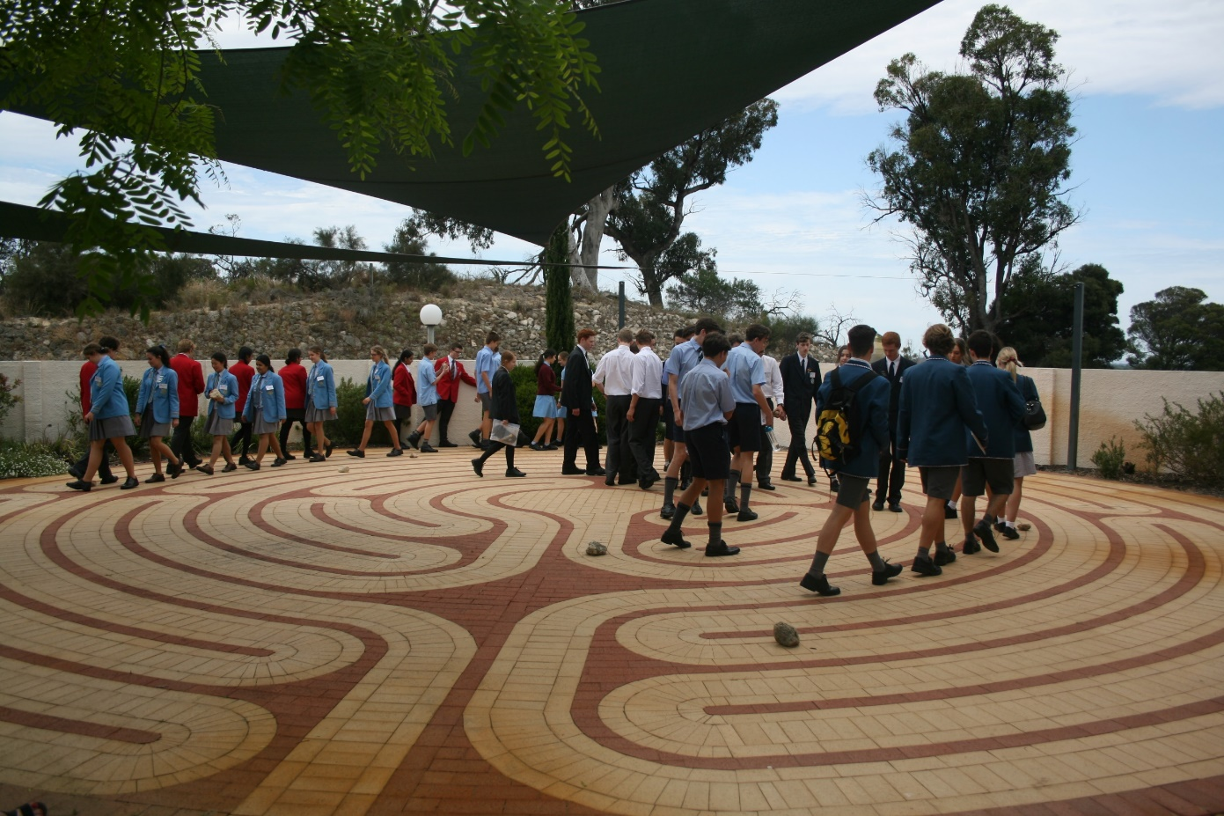

We encourage you to walk it with an open mind and an open heart

There are three basic stages to the walk:
1. The path into the centre …. let go, release, slowly
2. The centre ……. pause
3. The path from the centre … return on the same path

Pause at the entry to allow yourself to become fully conscious of stepping into the labyrinth. Here are some hints:
- Allow your body to find your natural pace. Your pace may change during different stages of the walk.
- Become conscious of your breath. Let it flow smoothly. It can be co-ordinated with each step if you choose.
- The narrow path is a two-way street. If you are going in and another person is going out, you will meet on the path. If you want to maintain an inward meditative state, simply do not make eye contact. You can “pass” people on the labyrinth, or allow others to pass you. Allow spaciousness within and honour your pace.
- Pause at the exit to allow yourself to become fully conscious of stepping back out into the world.
- Treasure and nurture your quiet mind. Don't be tempted to “talk the experience away‟, rush on, or over analyse it.
Honour your experience as you move on to your next session and then back into your school routine.

There is no right or wrong way to walk a labyrinth. If you approach it with an open mind, then anything that happens can serve as a blessing.
You might find yourself confused and “lost” on the path.
You could have an awkward moment as you meet a fellow walker on the same path. You might even become irritated that there are too many people in the labyrinth.
You could be determined to find an “answer” to a special question, but instead experience nothing. OR the answer might even come!!

Walking . . . balancing . . .people . . . perseverance . . . On the path we meet every and all things. Allow these moments to speak to you.

There are many ways to describe a labyrinth. Some call it a path of prayer, a walking meditation, a place of change, a watering hole for the spirit and even a mirror of the soul. However you might experience it, the Labyrinth can provide us with a spiritual resource, a pilgrimage-like walking that might take us into a very different place: just as meditation does.

In this way, the journey of the Labyrinth can also be a prayer for your friends, the world or yourself; a path away from an issue, and returning back renewed and refreshed; or even a meditation as you think about a verse in the Bible or use a mantra step by step – perhaps one of these:
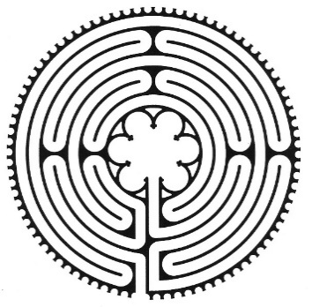
Come, Holy Spirit
I am a child of God
Jesus, have mercy
Maranatha
May I be filled with love
May I be at peace
