Name: …………………….
Class: …………………….

World Religions

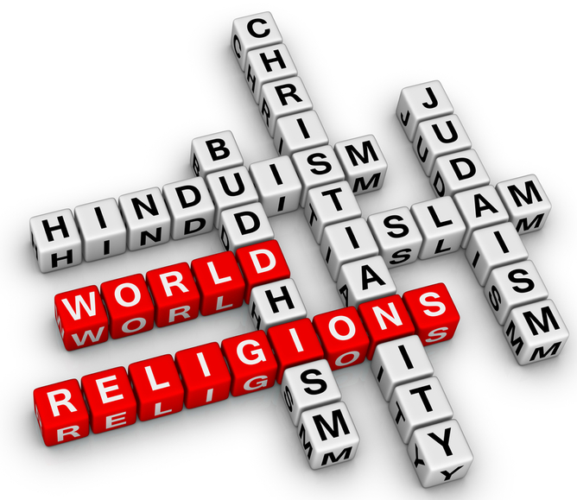
WorldReligions.com

We will be examining and compare the five major religions of the world: Christianity, Judaism, Islam, Hinduism and Buddhism. We will compare the beginnings, core teachings and practices of each. We will work through each religion addressing common questions. There will be research at the end into a festival of one of these religions. The program for the term will be as follows:

Week 1: Intro to World Religions
Week 2: What do you know
Week 3: Who is God?
Week 4: Christianity
Week 5: Christianity
Week 6: Judaism
Week 7: Judaism
Week 8: Judaism
Week 9: Islam
Week 10: Islam
Week 11: Islam
Week 12: Hinduism
Week 13: Hinduism
Week 14: Hinduism
Week 15: Buddhism
Week 16: Buddhism
Week 17: Compare

This booklet is provided with grateful thanks and acknowledgement of the foundational work of Stuart Shattock,
Head of Christian Studies at St Mark’s Anglican Community School, Hillary’s, WA.

WEEK 1 – What is Religion?

How would you describe a religion?

Why do you think people are religious?

What role do you think religion plays in our society?

What percentage of people do you think are religious?

Name three religions?

Rank the world religions in order of most to least followers as a percentage.

What are some things that religions claim to know?

“That’s true for you, but not for me.” Relativism
“Gravity – is true for you, but not for me.”
“Scott Morison is Prime Minister of Australia in 2021 – is true for you, but not for me”
“WWI Germany surrendered on 11 November 1918 – is true for you, but not for me”

Each religion claims it is true (not just opinion) but say different things. Can they all religions be true, why/why not?

How could you check a truth claim?

What things would be helpful to know about a religion?

Write at least two questions you have about religion?

WEEK 2 – What do you think you know about religions?

We will be looking at 5 world religions, Christianity, Judaism, Islam, Hinduism and Buddhism. Brainstorm what you think you know and what questions you would like answers to know.
Judaism

Islam

Buddhism

Hinduism

Christianity

What God has done, not what I do.
Each week as we work through the different religions you should summarize the points into the table on the next few pages.

Who is God?
- Name or names?
- Character, description of God
- What God has done?
- What does God need?
- What does God want?

Sacred text, how can I know God?
- Name of text
- Date when written
- Author/s
- How did the author know what to write?
- Any related material, further texts?

Universe, God and people?
- Brief creation description?
- Human purpose?
- God’s role in the world now?

Death, judgement and heaven?
- What happens after death?
- Judgment of me based on what?
- What is heaven about?
- What is hell about?

Life, how should I live?
- What things should I do regularly in life?
- Main festivals?

Important people and dates?
- Who started the religion and when?
- Any background before them?
- Key people after them?
- Leaders today and their role?

 | Christianity | 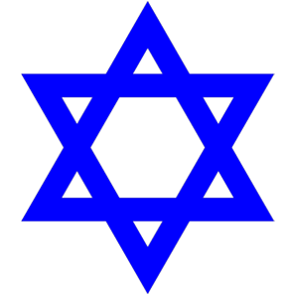  Judaism
Who is God?
Sacred text, how can I know God?
Universe, God and People
Death Judgment and Heaven
Life, how should I live and important festivals?
Important People and Dates
Questions or Fun Facts
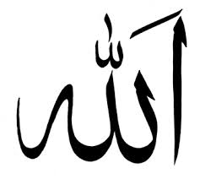  Islam | 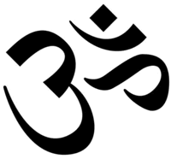  Hinduism | 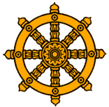  Buddhism
WEEK 3 – Who is God?

A creed is a statement about belief, a summary. The Nicene Creed is below this is a summary of belief based on the bible used since the early church. A lot of what is central to Christianity is included.

We believe in one God,
the Father almighty,
maker of heaven and earth,
of all things visible and invisible.

And in one Lord Jesus Christ,
the only Son of God,
begotten from the Father before all ages,
God from God,
Light from Light,
true God from true God,
begotten, not made;
of the same essence as the Father.
Through him all things were made.
For us and for our salvation
he came down from heaven;
he became incarnate by the Holy Spirit and the virgin Mary,
and was made human.
He was crucified for us under Pontius Pilate;
He suffered and was buried.
The third day he rose again, according to the Scriptures.
He ascended to heaven
and is seated at the right hand of the Father.
He will come again with glory
to judge the living and the dead.
His kingdom will never end.

And we believe in the Holy Spirit,
the Lord, the giver of life.
He proceeds from the Father and the Son,
and with the Father and the Son is worshiped and glorified.
He spoke through the prophets.
We believe in one holy catholic and apostolic church.
We affirm one baptism for the forgiveness of sins.
We look forward to the resurrection of the dead,
and to life in the world to come. Amen.
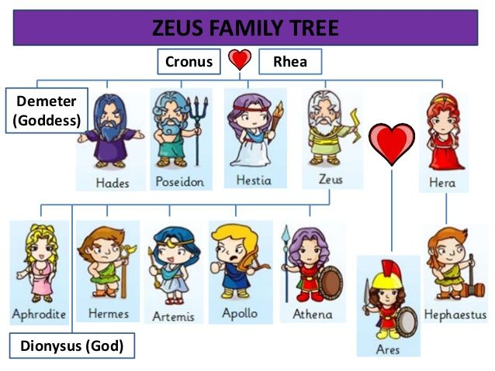
WEEK 3 – Who is God?

Who is God? The Lord your God is one. The Bible holds a very different view of God from that of the rest of the ancient world. The polytheism of Egypt, Greece, Rome, Norse is striking different to the monotheistic God of the Jewish, Christian, and Islamic faiths.

Is anything too hard for God?

Who is God?
Monotheism, Christian Creed
Who are the Gods? Polytheism, Greek Gods

WEEK 4 – Christianity

Christianity
Christians believe in one God that exists in three persons—the Father, the Son (Jesus Christ), and the Holy Spirit. The core beliefs of Christianity are summarized in 1 Corinthians 15:1-4. Jesus died for our sins, was buried, was resurrected, and thereby offers salvation to all who will receive Him in faith.
Unique among all other faiths, Christianity is about a relationship instead of religious practices. Instead of a list of “do’s and don’ts,” the goal of a Christian is to follow God. That relationship is made possible because of the work of Jesus Christ and the ministry of the Holy Spirit NOT by rules or what I do.

http://www.bbc.co.uk/religion/religions/christianity/

Who is God? Watch “How is God both one and three?” 8mins
Trinity - Father, Son (Jesus), Spirit

Sacred Text, how can I know God? Watch “The Bible” 6mins
Bible

Universe, God and people?

Death, judgement and heaven?

Important people and dates? (why are they important and when did they live)

Jesus

Martin Luther

Pope

WEEK 5 – Christianity

Life, how should I live? Micah 6:8

Find the following verses and match them below and summarise them.
1Tim 2:1-4, Eph 2:8-10, 1Peter 3:15-17, Heb 10:24-25, 1Cor 11:23-26, Matt 28:19-20

Actions or Deeds

Telling Others

Church

Communion

Baptism

Prayer

T hankyou
S orry
P lease

A doration
C onfession
T hanks
S upplication

Our Father in heaven, hallowed be your name,
your kingdom come, your will be done, on earth as in heaven.
Give us today our daily bread.
Forgive us our sins as we forgive those who sin against us.
Save us from the time of trial and deliver us from evil.
For the kingdom, the power, and the glory are yours now and forever. Amen.

Christianity is about what God has done for me because he loves me so that I can have a relationship with him, not what I do with rules to make him love me. What is the focus of all of the above aspects of Christianity and of those festivals below?

Me and what I do OR What God has done for me

Christmas

Good Friday

Easter

WEEK 6 – Judaism

Judaism: Believes in one God (like Christianity & Islam) but also rejects the claim that Jesus is God or anything more than a prophet (like Moses or Elijah). Judaism therefore, is still waiting for and expecting the coming of the promised messiah.

My Life, My Religion: Judaism (29 minutes) make notes on the headings below.

What is Judaism?

Jerusalem (Capital of Israel)

Western wall (last remnant of the Temple)

Shabbat (Sabbath)

Torah

Kosher

Bat / Bar Mitzvah

Passover

WEEK 7 – Judaism on a page

Who is God? Yahweh

There is only one G-d M_________________
G-d is beyond time and space E________________
G-d is spirit and is always everywhere O_____________________
G-d is all-powerful O_______________
G-d is all-knowing O_______________
G-d made the universe and everything in it. He is the C________________
G-d has a purpose for the world
G-d is completely good and loving B _______________
G-d cares how we behave, and he J ____________ each individual.

Overview

Judaism begins about 2000 BC with the covenant between G-d and A___________. G-d makes three promises to him, N________, L________ and B__________ to all.
Judaism has influenced C__________, I__________ and the B__________ faith.

Jewish Texts

Tanakh, the same as the Christian Old Testament, 39 separate books written between 1500 - 400 BC. Three parts T_________, N_________, K___________

Talmud, the teachings of the r________ over the centuries. Two main sources are the M__________ written in 200 AD and the G________ written in 500 AD.

What are some special rules for using a Torah scroll? Watch “The Torah” 6min

Basic Jewish beliefs

These are quite similar to Christianity, (Jesus and his disciple were all Jewish) but there are a few differences. Some differences are…

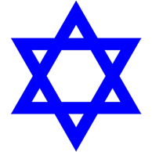
Jewish Practices

Sabbath –

Law –

Synagogue –

Annual Festivals include –

Why are there no sacrifices at the Temple today? Hint 70AD

Important people and dates?

The Messiah will c___________, Jesus is not the m____________.
Why did the Messiah mean so much to Jews?

Abraham lived about 2000BC, important because of the covenant for his descendants.

Moses, lived ___________, important to the Jews because

What Judaism says about…

Mankind and salvation

Can a Jew be a Christian?

WEEK 8 – Judaism

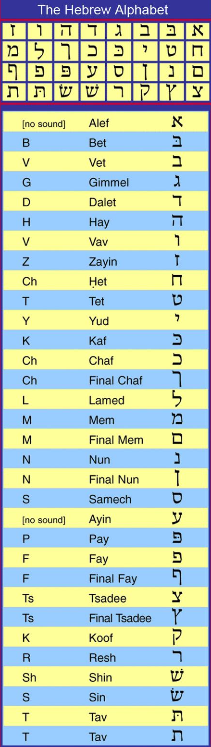
Write your name below in Hebrew

If you are a boy write the following 3 things:
your first name, ben (son of), your father’s first name

If you are a girl write the following 3 things:
your first name, but (daughter of), your mother’s first name

PETER BEN PHILIP SARAH BUT ALISON

If your name has a Y or EE sound in it, like Steven or Amy add a Y to your name – like this:

PETER = PEYTER AIMIE =AYMIEY

If your name ends in A add an H on the end
REBECCA = REBECCAH
Now cross out all the vowels (A,E,I,O,U), unless they are at the beginning of the name – like this:

PEYTER BEN PHILIP SARAH BUT ALISON

Write out the remaining letters:

PYTR BN PHLP SRH BT ALSN

Write out the name backwards! (Hebrew reads from Right to Left)

PLPH NB RTYP NSLA TB HRS

Replace the English letters with Hebrew letters. If you still have a vowel (A,E,I,O or U) use the letter aleph (which actually has no sound!) Things to watch out for:
• P and PH use the same Hebrew letter (pay)
• For TH use tav
• For SH use shin
• For CH use chaf
• For J use yud
• For vowels at the beginning of a word use alef
• For W and for OO sounds (as in Susan) use vav

WEEK 8 – Judaism

The Shema (Deuteronomy 6:4-5)
Hear,____________________________________________________________________________________________________________________________________________________________________________________________________
___________________________________________________________________
Shema means _______________________________________________________

God’s name

EHYEH – I will be (God can say this)

YEHWEH – He will be (We can say this referring to God)

ADONAI – LORD (Be careful with God’s name so say LORD instead)

YAHOWAH (translated into JEHOVAH) – a word to remind them to say ADONAI

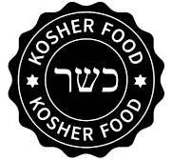
Kosher

Synagogue

WEEK 9 – Islam

Islam: Believes in one God (like Christianity & Judaism) but rejects the claim that Jesus is God or anything more than a prophet. Islam believes that God (Allah) is a supreme and perfect being who is distant from this evil world - though he is in control over it. It is therefore deeply insulting to Islamic belief to suggest that God would become a frail human and live and die in this evil world. A supreme and perfect being cannot do such a thing.

My Life, My Religion: Islam
Watch the following clip (29 minutes) and make notes on the headings below.

What is Islam about

The Kabah

Muhammad

Qur’an or Koran

Mosque

Wudu

Prayer

Ramadan

Hijab

WEEK 10 – Islam on a page
Islam is the youngest of the major world religions, founded by the prophet M_______________. It has two major groups Sunni and Shi’ite.

Islam’s Beginnings

Muhammad was born in the year _____AD in the town of ________. In 610 AD when he was 40 years old he mediated in a cave (Hira) near Mecca and there Muhammad was visited by the angel Gabriel with a revelation from Allah. He could not r_______ or w________ so memorized the revelations. His followers wrote them down over Muhammad’s lifetime and they became the K________ or Quran.

He fled from Mecca to the town of ___________. He retuned 8 years later with an army and took control of Mecca. He destroyed the idols in the Ka’bah. He died in the year _____AD.

Watch “How Islam began” 8 mins and record notes and questions about Muhammad’s life.

Source of Authority

Muslims believe Allah has many written works including the Old and New Testaments. However these have been c____________ and are not trustworthy.

The Qur’an or Koran, is the W_______ of G______.

Customs to follow are recorded in the Hadith a record of sayings and conduct of Muhammad and his companions.

Watch “The Qur’an” 10 mins and record notes and questions about the Qur’an and the Hadiths.

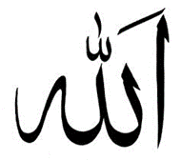
Religious Duty, the Pillars of Religion

1

2

3

4

5

Are God and Allah the same?
Similarities

Differences

“Allah loves not those that do wrong”
Allah will J___________. The Qur’an teaches that our g______ deeds must outweigh our b____ for us to enter heaven. These deeds are recorded for each person by two angels one on each shoulder.

M_____________ warns of Allah’s judgement but also says that “No bearer of a burden can bear the burden of another.
How is this different to Christianity?

WEEK 11 – Life as a Muslim
Islamophobia, Jihad, Mosque, Halal…
Islamophobia

Mosque

Jihad

Halal

Salt water, air in a jar

Brahman –

Atman –

Maya –

WEEK 12 – Hinduism basics

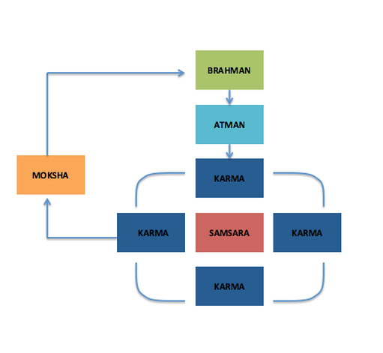
Groundhog Day

Reincarnation –

Samsara –

Moksha –

My Name is Earl

Karma –

Dharma –

What are some thing you have to do?

What are some things your parents must do?

What do you feel is the ultimate goal in being a human?

WEEK 13 – Hinduism

Hinduism: Believes in tiers (or levels) of multiple gods (millions) with one supreme "being" called Brahman. All things are part of Brahman, but the world as we know it has been separated from him and is therefore evil. All people need to escape the physical world by reaching enlightenment and be rejoined with Brahman. Enlightenment is reached through lifelong dedication to one of the many gods. If enlightenment is not reached in your lifetime, you will continue to be returned to the physical world after death by reincarnation. If you lived a good life devoted to your god then you are reincarnated to a better position, if you lived a bad life you will reincarnated to a worse position.

My Life, My Religion: Hinduism
Watch the following clip (29 minutes) and make notes on the headings below.

What is Hinduism about

Raksha Bandhan

Cycle of Life (Samsara)

Moksha

Funerals

Pilgrimages

Marriage

Holi

Diwali
WEEK 14 – Hinduism on a Page

Origins

Hinduism was founded in I________ in a simple form around 2500 BC. The name comes from the I___________ river. It has no single founder. However in 600 BC it changed from focusing on external rituals to more i_________ m_________.
Hinduism has many different views of God and the universe, with as many as 330 million gods. Three other religions have come from Hinduism, J____________, B____________, & S_____________.

Who is God?

Brahman is an i__________ force or essence beyond all distinctions. Brahman cannot be known or worshiped. Brahman is “an impersonal, omnipresent (in all places) being, NOT knowing or thinking or reasoning or creating being, because these are all signs of weakness. (see page 18)

There are lots of Ishvara (personifications of Brahman or Gods) ______ million.

The three main Gods are (find out a little of each google)

Brahma -

Vishnu -

Krishna (avatar of Vishnu)

Shiva -

Find out about two others (google)

Watch “How Lord Ganesh got his Elephant head” 3 mins

The scriptures in Hinduism are viewed as eternal, with no historical reference, like the dreamtime in Aboriginal spirituality.
Hindu Scriptures

Vedas, instructions for doing r___________

Oldest surviving copy of a Veda (google)?

When did they originate and when were they first written down (google)?

Smriti –

Hindu Worship

Hinduism has no creed or final truth but is a broad collection of scriptures with diverse beliefs. So worship is mostly individualistic and varied but can include…

Paths to Moksha

Moksha is the goal of life for Hindus, to return to Brahman

1 Dharma –

2 Inana –

3 Bkakti –

Caste System

1 P

2 W and N

3 M and A

4 S
How would you know if all this is true? Or how would you test it?

WEEK 15 – Buddhism

Buddhism: Is a philosophy that rejects the existence of any deity (god) and is therefore essentially an atheistic religion. Like Hinduism, Buddhism is about trying to remove yourself from the suffering of this world through enlightenment. Enlightenment is reached by emotionally distancing yourself from the world and others. All feelings, whether happy or sad, are evil because they lead to suffering. If enlightenment is not reached in your lifetime, you will continue to be returned to the physical world after death by reincarnation.

3 universal truths
- Anicca – All things are impermanent, they are constantly changing.
- Anatta – There is no permanent identity or separate self.
- Dukkha – Suffering or unsatisfactoriness, the failure of life to give satisfaction.

4 noble truths
- All life involves suffering, dukkha. (what is wrong)
- The origin of suffering is craving, samudaya. (the cause of suffering)
- If craving stops, suffering will also cease, nirodha. (how to end suffering)
- The middle way or 8 fold path, will end suffering, magga. (how to live)

8 fold path

Watch The Life of Buddha (49 minutes total, if short for time, watch first 3 minutes then skip to 14 minutes in) and make notes on the headings below. http://goo.gl/X0Vt3u

When and who started Buddhism

Siddartha’s birth and early life

Four signs

Buddhism is a philosophy in response to?

Brahmins (Hindu priests) had what

Middle way (8 fold path)

Enlightenment

Taught

Died

WEEK 16 – Buddhism on a page

Buddhism was founded in northern India, by the Hindu prince S________________ Gautama who lived about 563 – 483 BC.

Rejecting Hinduism and its rigid unjust system, the Prince left behind his wife, child, lifestyle, and leadership to search for an answer to the suffering he saw in the world. In time he found the middle way through moderation and mediation. He achieved nirvana (to understand the causes of suffering and “blow them out”) and became the Buddha or enlightened one. The rest of his life was spent sharing what he had learnt.

The Buddha’s T_________ – Dharma
Buddha’s R_______ for nuns and M________ – Vinaya
These teachings and rules where collected and written down 200 years after Buddha his death in the Pāli Canon or T__________

Types of Buddhism

No God, in traditional T__________ Buddhism (300 yrs after Buddha). They use theonly the original teaching for Buddha the Pāli Canon.

M___________ Buddhism (reformed Buddhism out of India, 600 years after Buddha) worships Buddha as a God along with other G_____. Special teachings are added to B__________’s originals from future Buddhas who return to this world to guide others.

Vajrayana Buddhism includes many spiritual techniques and by harnessing psycho-physical energy you may achieve enlightenment in one lifetime.

Z____ Buddhism has no need for any text as teachings are transmitted from mind to mind with no need for words. Zen was developed ______ years after the death of the Buddha “Look W____________, you are the Buddha” and it stresses finding your own way. It involves much Zen meditation.

Key Beliefs

Buddha taught Three Universal Truths, Four Noble Truths and the Eightfold Path to live by to achieve nirvana.

YOU do not truly exist. Merely the I___________ of you caused by five parts.
To live is to S____________ because of our A______________.
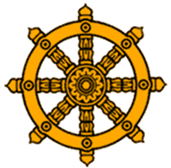
S______________ is the cycle of death, birth and rebirth which has been going on forever.
Good and bad deeds have C_______________ or causation in the next life, Karma.
The goal of life is to achieve N__________, eliminating desire and finally the complete ending of the illusion of YOU when you die and are not R_____________.
If the Buddha was just a man, why follow him and his teachings over any other wise teacher or philosophy?

No heaven or hell, but to live is suffer. Will dying end suffering then?

“To seek is to suffer, to seek nothing is bliss” Bodhidharma

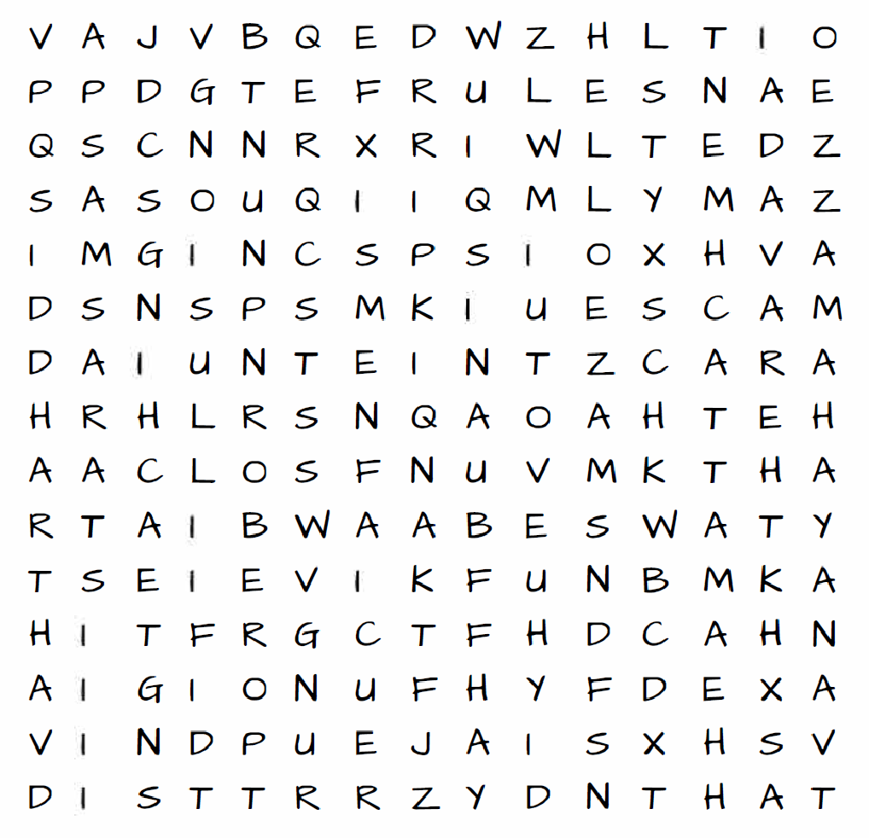
Siddhartha
Teachings
Rules
Monks
Tripitaka
Theravada
Mahayana
Gods
Buddha
Zen
Within
Illusion
Suffer
Attachment
Samsara Consequences
Nirvana
Reborn

WEEK 17 – Final comparison and review

How can we be sure Christianity is true?

The question "why are we right and they wrong?" is probably not the most helpful question to ask because it involves a measure of arrogance and makes the focus of the question more about human pride than seeking a truthful answer… Nevertheless, why does Christianity stand out as more convincing than other religions?
Because Christianity makes an historical claim that is open to the process of historical investigation.
That central claim is that God walked upon this earth in a specific place, at a specific time in history, which means that you can test Christianity by historical processes. And the evidence is compelling, that Jesus said what he said, did what he did, and is who he claimed to be.

What do Christians believe? http://goo.gl/8Wr0Sy

How is Christianity different from other religions? http://goo.gl/znsXIC

How do you think Christianity compares to other religions, what do you think and why?

