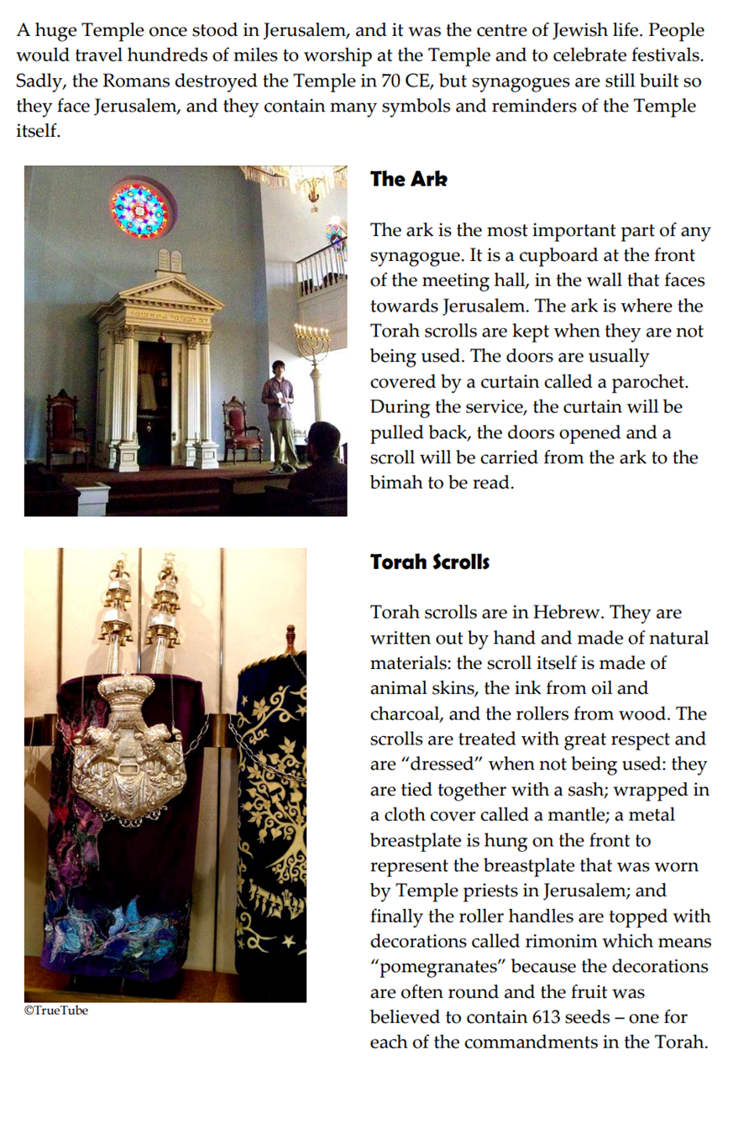
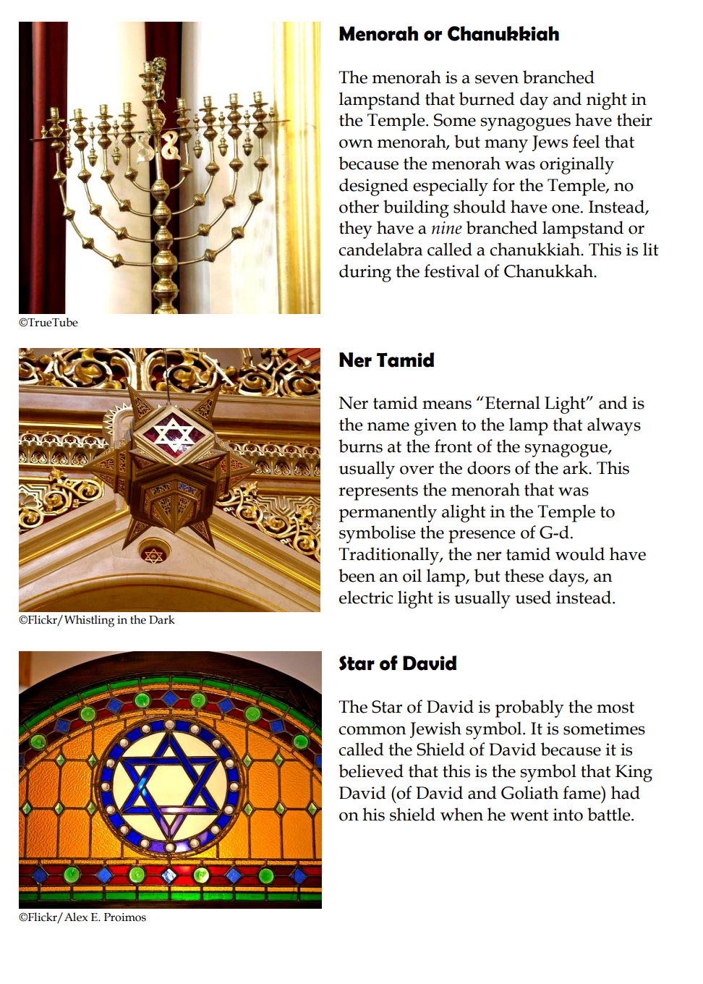

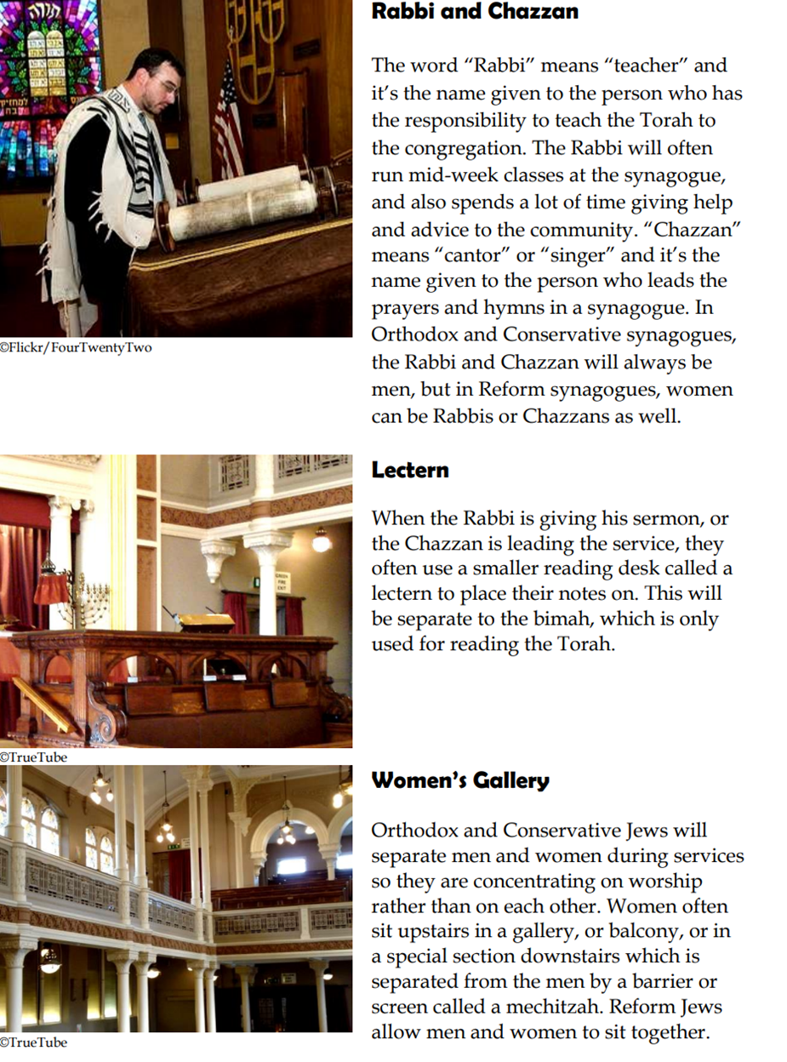

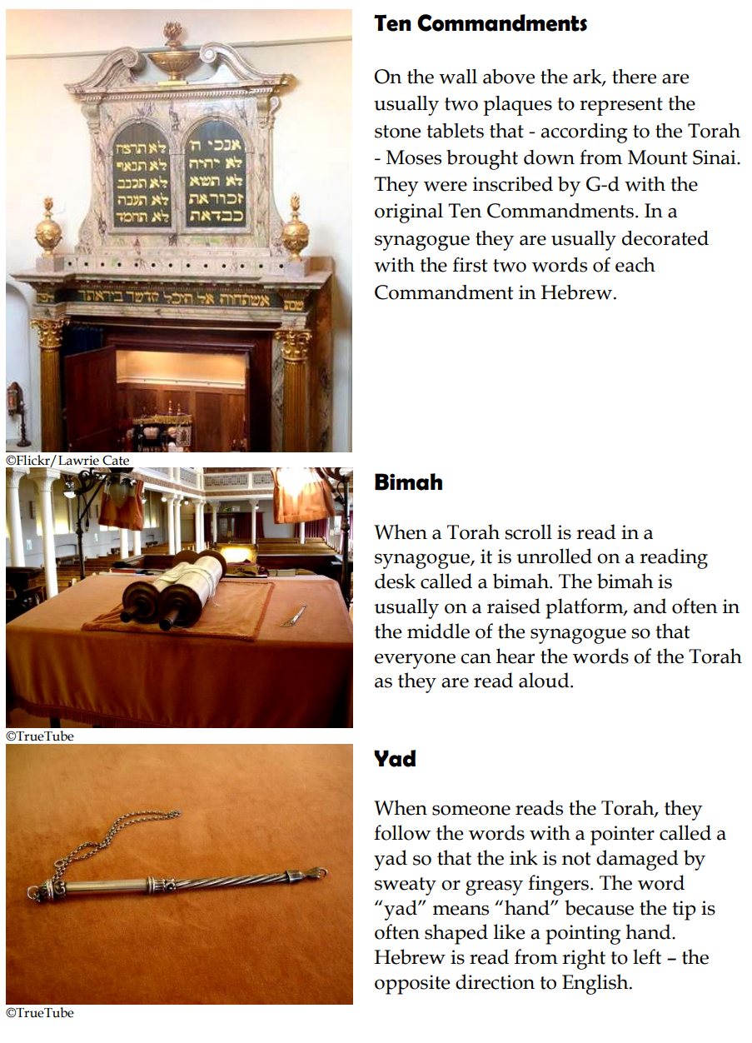

Kippah

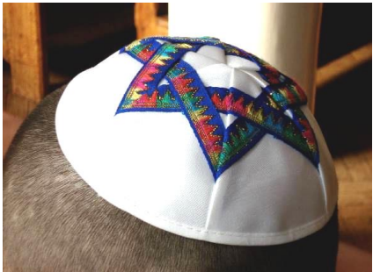
In Orthodox and Conservative
synagogues men are expected to cover
their heads as a sign of respect to G-d. They usually wear a skull cap called a
kippah, or yarmulke. Married women are
expected to cover their heads at all times
with a hat, scarf or wig. Unmarried
women might choose to cover their heads
as well.
©Flickr/Old Shoe Woman

Tallit

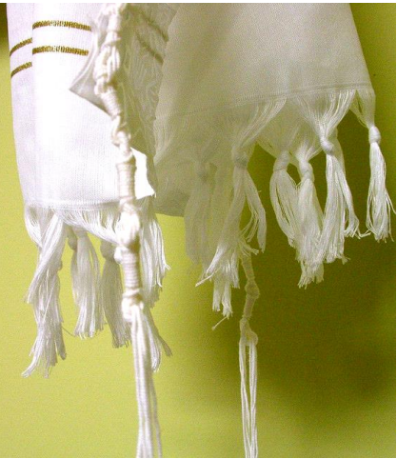
Jews wear a special shawl called a tallit
whenever they pray at home or in the synagogue. The shawl has fringes called
tzitzit which represent the 613
Commandments in the Torah. The shawl
reminds Jews that they should be
following G-d’s commandments
whenever they put it on.
©Flickr/chaim zvi

Tefillin
Tefillin or phylacteries are small boxes
containing tiny scrolls with words from
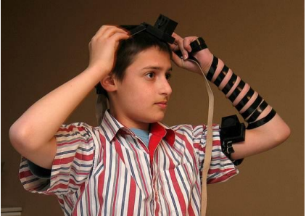
the Torah written on them. They are
attached to leather straps so they can be
worn in a particular way on the head and
on the left arm. The Torah says, “Bind
these words as a sign on your hand, and
let them be an emblem in the centre of
your head”, so many Jews do just that
while they pray to remind themselves of
the importance of G-d’s words. Tefillin
are used during private prayer and so
they are not usually worn at the
synagogue.

?

